**AI For Trading**

**Project : Trading with Momentum Project**

In this project, you will learn to implement a trading strategy on your own, and test to see if it has the potential to be profitable. You will be supplied with a universe of stocks and time range. You will also be provided with a textual description of how to generate a trading signal based on a momentum indicator. You will then compute the signal for the time range given and apply it to the dataset to produce projected returns. Finally, you will perform a statistical test on the mean of the returns to conclude if there is alpha in the signal. For the dataset, we'll be using the end of day from Quotemedia.

**Project : Breakout Strategy Project**

In this project, you will implement the breakout strategy. You'll find and remove any outliers. You'll test to see if it has the potential to be profitable using a Histogram and P-Value. For the dataset, we'll be using the end of day from Quotemedia.

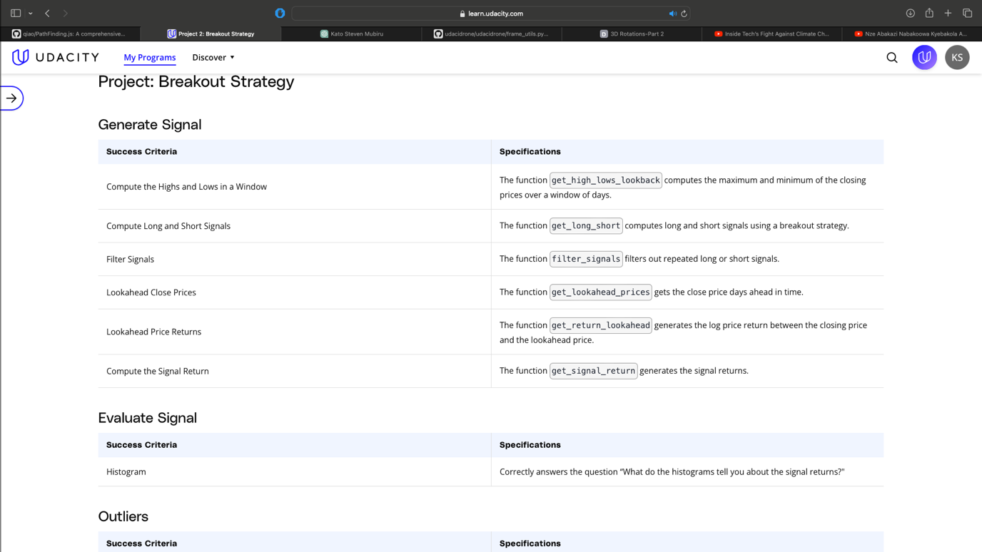

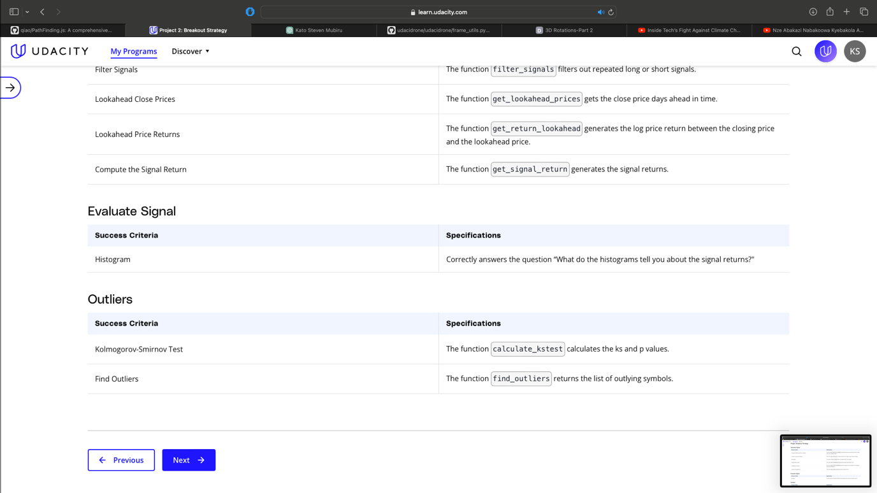

**Project 3: Smart Beta and Portfolio Optimization**

Smart Beta and Portfolio Optimization

In this project, you will build a smart beta portfolio and compare it to a benchmark index. To find out how well the smart beta portfolio did, you’ll calculate the tracking error against the index. You’ll then build a portfolio by using quadratic programming to optimize the weights. Your code will rebalance this portfolio and calculate turn over to evaluate the performance. You’ll use this metric to find the optimal rebalancing Frequency. For the dataset, we'll be using the end of day from Quotemedia.

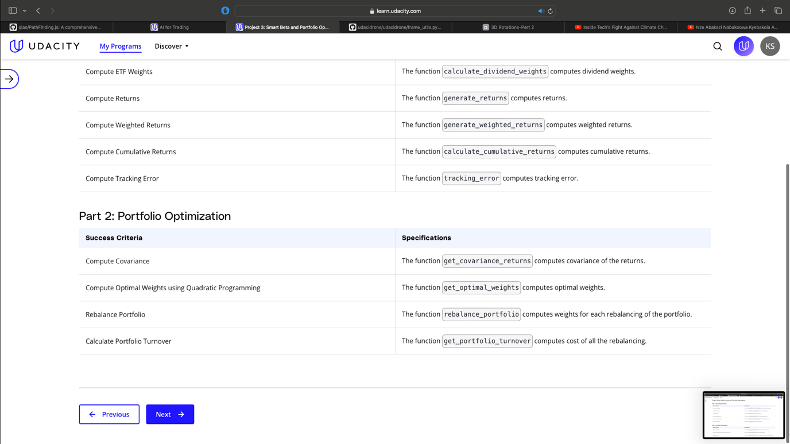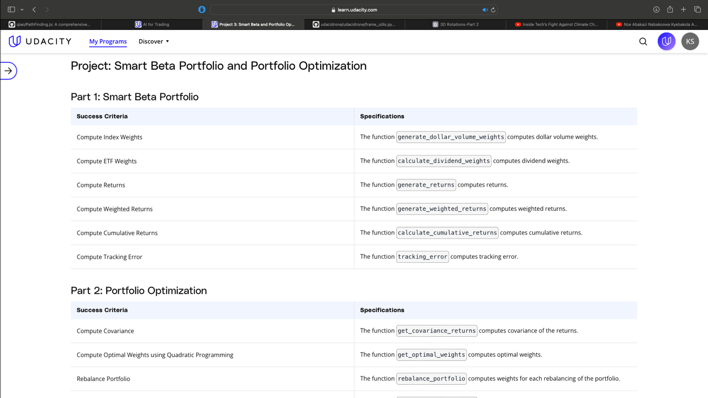

**Project 4: Alpha Research and Factor Modeling**

In this project, you will build a statistical risk model using PCA. You’ll use this model to build a portfolio along with 5 alpha factors. You’ll create these factors, then evaluate them using factor-weighted returns, quantile analysis, sharpe ratio, and turnover analysis. At the end of the project, you’ll optimize the portfolio using the risk model and factors using multiple optimization formulations. For the dataset, we'll be using the end of day from Quotemedia and sector data from Sharadar.

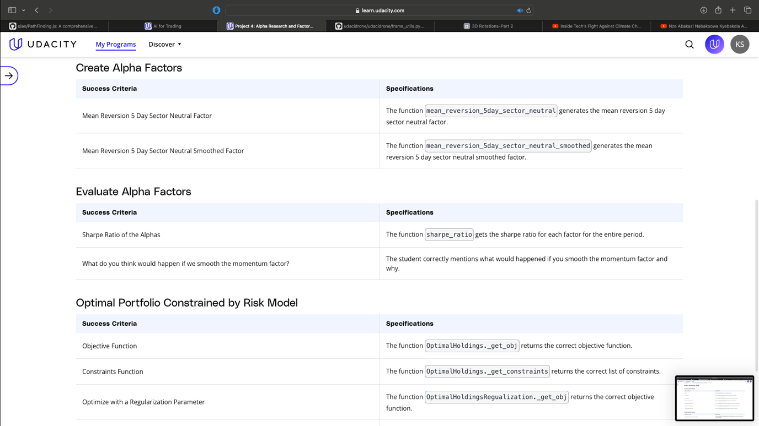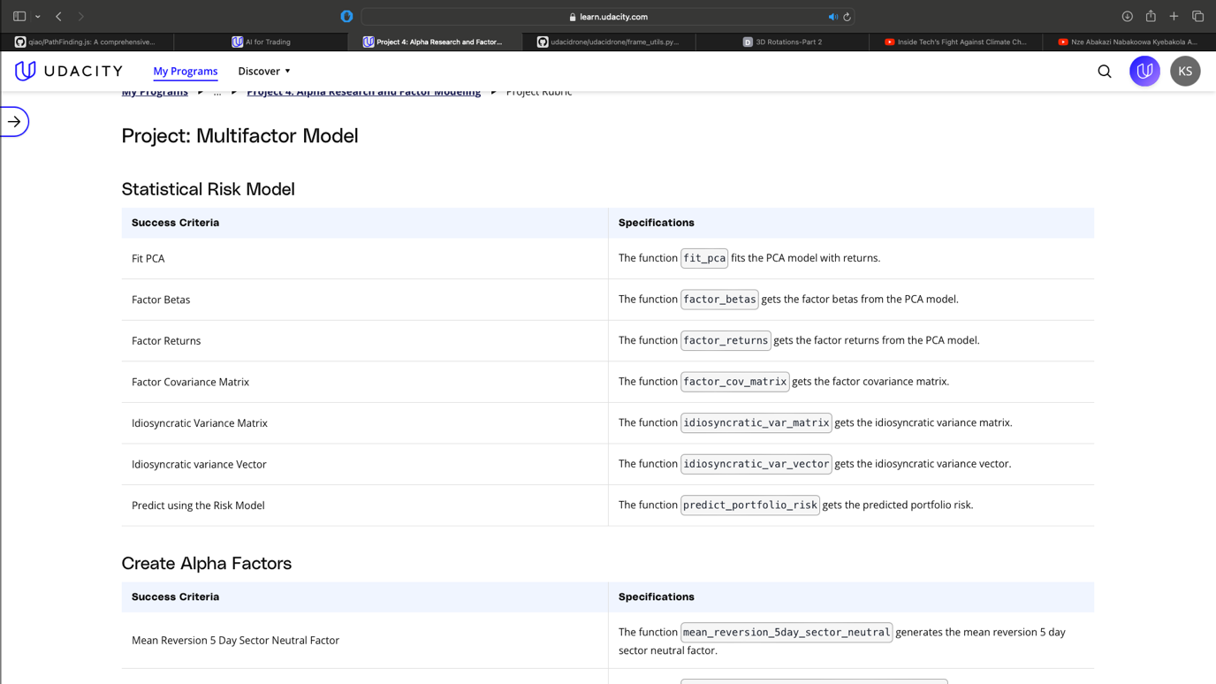

**Project 5: NLP on Financial Statements**

In this project, you'll do NLP Analysis on 10-k financial statements to generate an alpha factor. For the dataset, we'll be using the end of day from Quotemedia and Loughran-McDonald sentiment word lists.

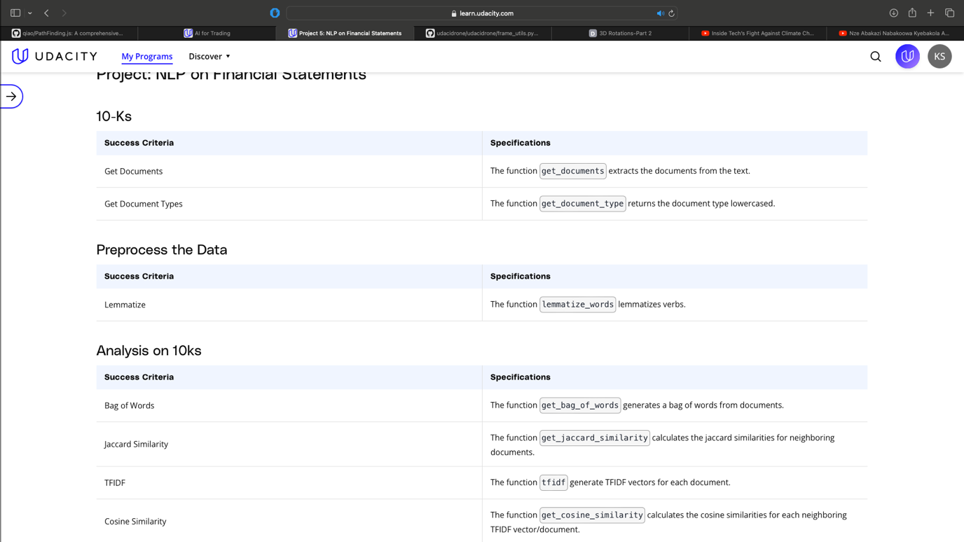

**Project 6: Sentiment Analysis with Neural Networks**

In this project, you'll build your own deep learning model to classify the sentiment of messages from **[StockTwits](https://stocktwits.com/" \t "_blank)**, a social network for investors and traders. Your model will be able to predict if any particular message is positive or negative. From this, you'll be able to generate a signal of the public sentiment for various ticker symbols.

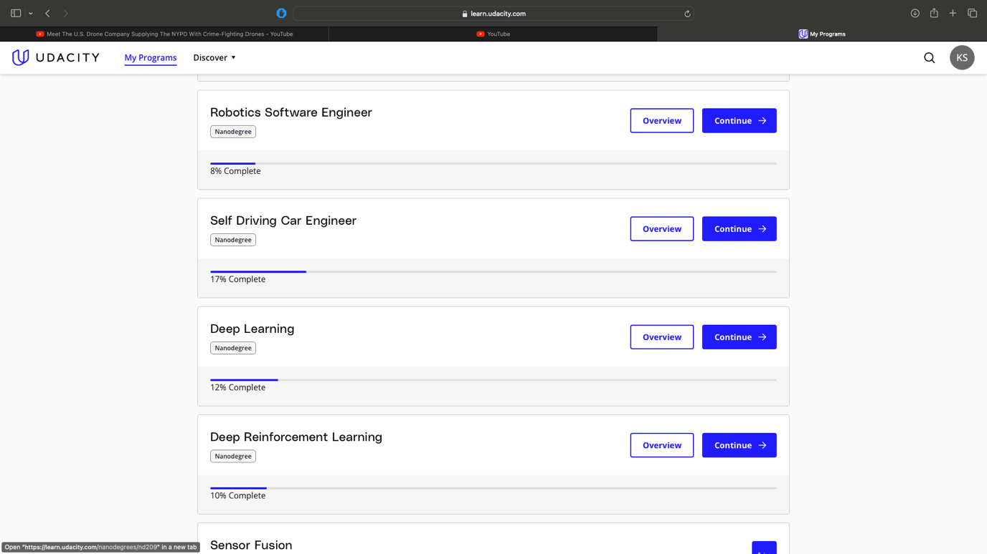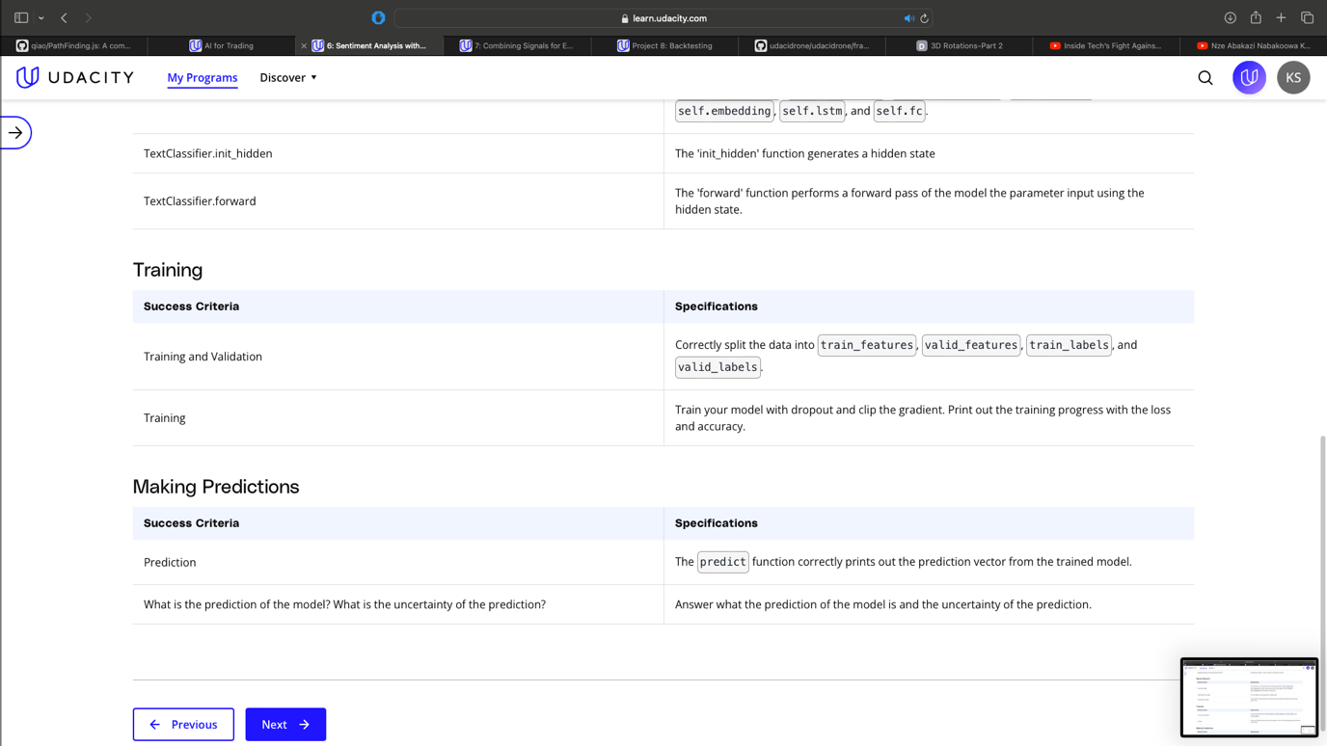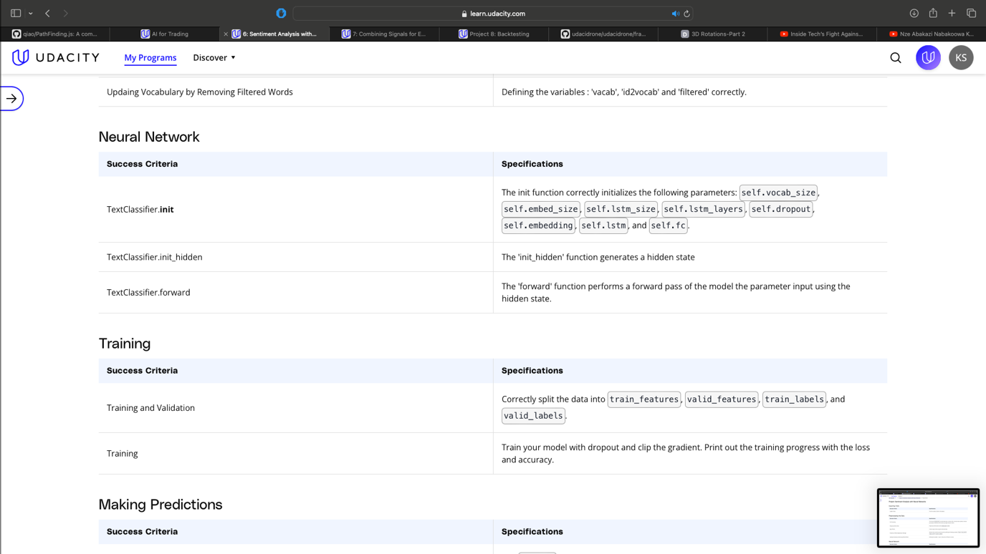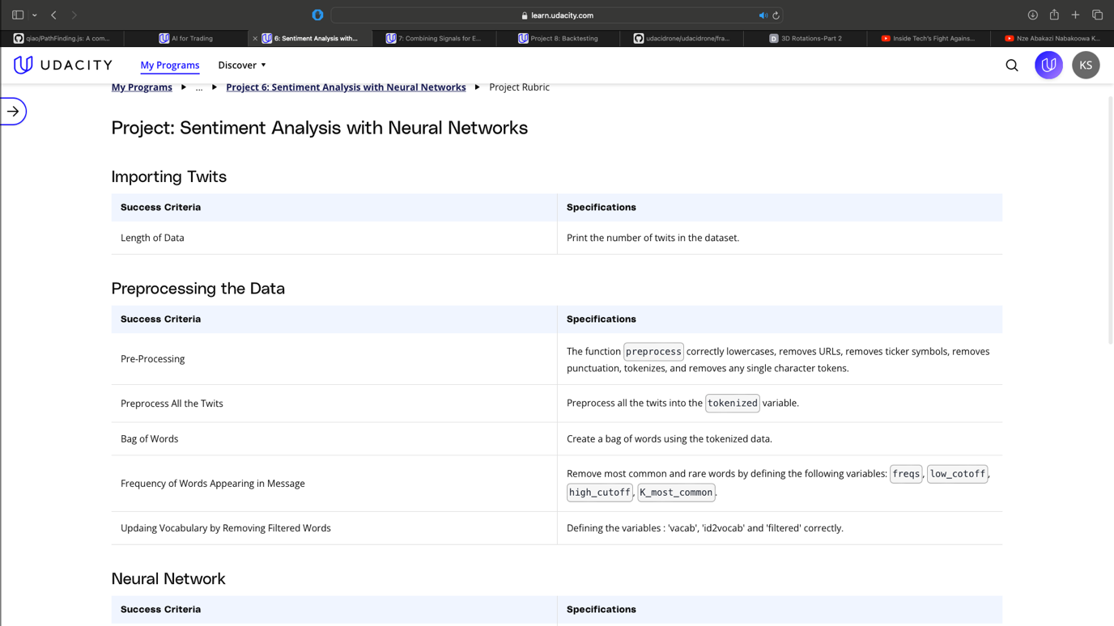

**Project 7: Combining Signals for Enhanced Alpha**

In this project, you'll combine signals on a random forest for enhanced alpha. While implementing this, you'll have to solve the problem of overlapping samples. For the dataset, we'll be using the end of day from Quotemedia and sector data from Sharadar.

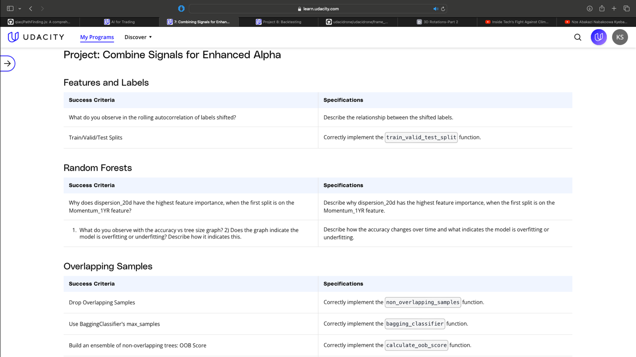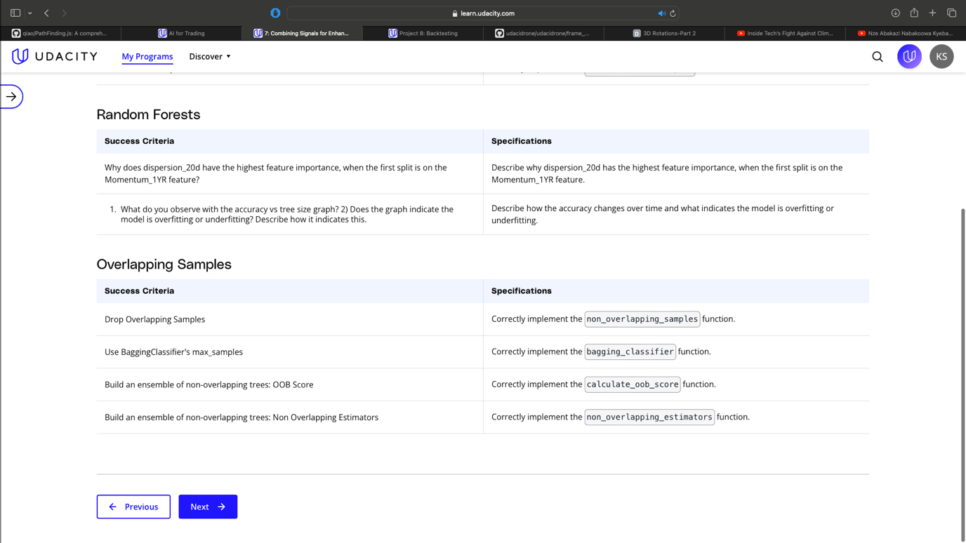

**Project 8: Backtesting**

In this project, you will build a fairly realistic backtester that uses the Barra data. The backtester will perform portfolio optimization that includes transaction costs, and you'll implement it with computational efficiency in mind, to allow for a reasonably fast backtest. You'll also use performance attribution to identify the major drivers of your portfolio's profit-and-loss (PnL). You will have the option to modify and customize the backtest as well.

**Suggestion to customize your project**

* Try backtesting on different time periods and interpret the final results.
* Try different factors to be their alphas.
* Try different weights for each alpha, based on some metric that tells us how confident we are in that alpha, such as a rolling average of the sharpe ratio for each alpha factor.
* Try different transaction cost models. Read the paper [**"Crossover from Linear to Square-Root Market Impact”.**](https://arxiv.org/pdf/1811.05230.pdf) It has a good overview of the transaction cost models, and it also references other papers that are useful in studying transaction cost models.
* Note about testing previous alphas: To test the alphas that you've created using the QuoteMedia data source, we would need a mapping file that identifies which cusip is associated with which barra ID. We currently aren't able to provide this in the classroom.

